Hillary Loyd

Dr. Brian Holbert

CS-330: Comp Graphic and Visualization

July 10, 2022

Project Proposal

The scene that I have chosen to recreate is one that I just made up of objects around my house. These objects are things that I or my son uses frequently and is a part of our everyday life. All the items in the pictures below will be recreated in 3D. I think that all of these are good choices because while the Switch may seem difficult to recreate it has only a few shapes to it. All these objects are simple but give the idea of a complex object. Making these great objects to represent size, shapes, and ease of the items.

Breaking down the objects we have the background, an egg, Thumb tack, a remote control, and a Nintendo Switch. The background of this picture can be represented by just using a plane. This will act as the ground in which the rest of the items are set on. The egg is made of a sphere. While I wanted a ball of this object and could not find one in my house I do think that I can get an egg shape with a sphere. The thumb tack can be made up of a torus on the top and bottom of the head of the tack and a cylinder connecting them. The needle of the tack can be represented by a cylinder and for the point I was thinking triangles. The remote is the object that uses the most shapes to create. The back of the remote has a triangular shape. It also uses cubes for the rest of the shape and some of the buttons. A plane or a cube can be used for the silver button in the middle, while cylinders will make up the rest of the remaining buttons on the remote. The Nintendo Switch is made up of three objects. A cube for the main shape of the Switch and some of the buttons. Like the remote we can us Cylinders to make up the rest of the buttons. The Joysticks are made up of cylinders and a torus at the top with the cylinder going through it. I do believe that all of these are achievable to recreate. While I may not know a lot 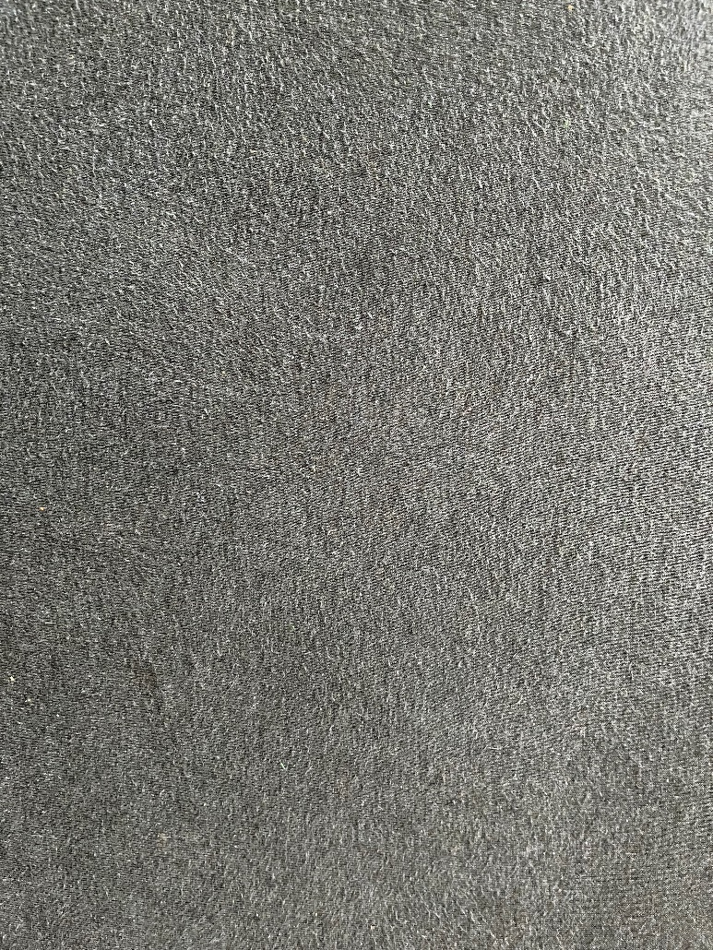about OpenGL, I think that with these objects it will really let me get a feel for it. I am a hands-on learner so diving in is very exciting and I look forward to seeing how it turns out.

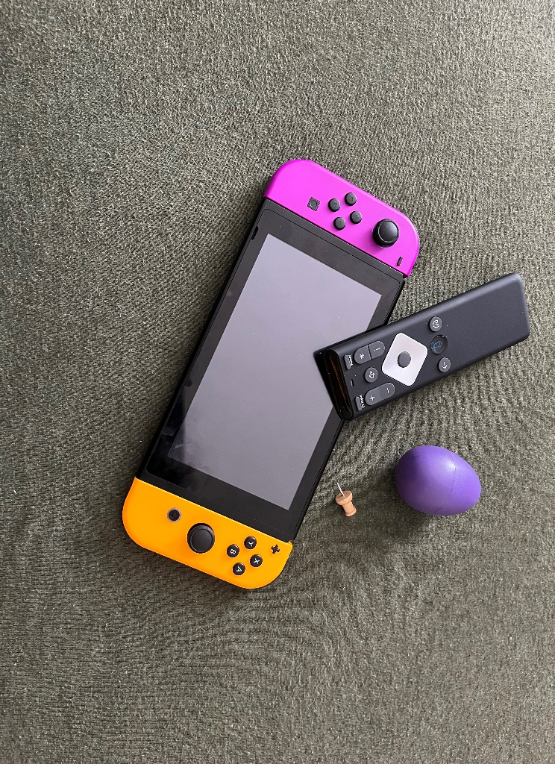Background

Top View

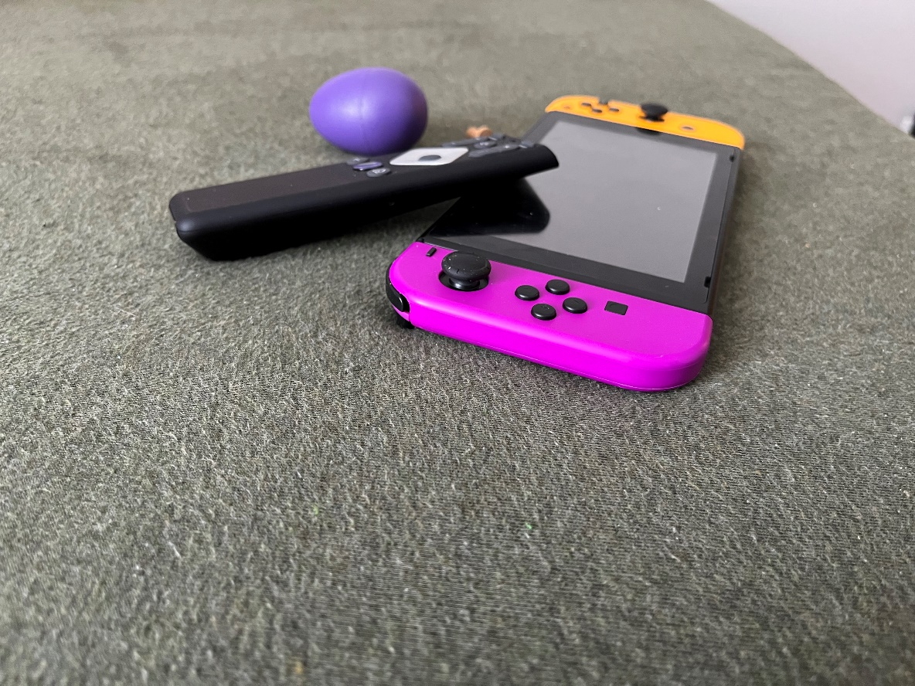Left View

Right view

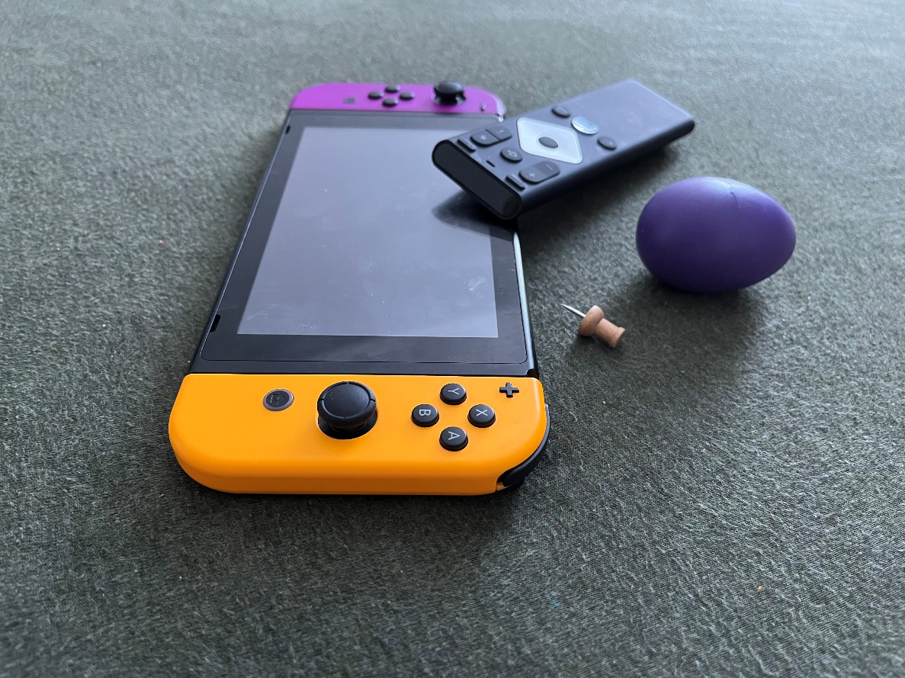

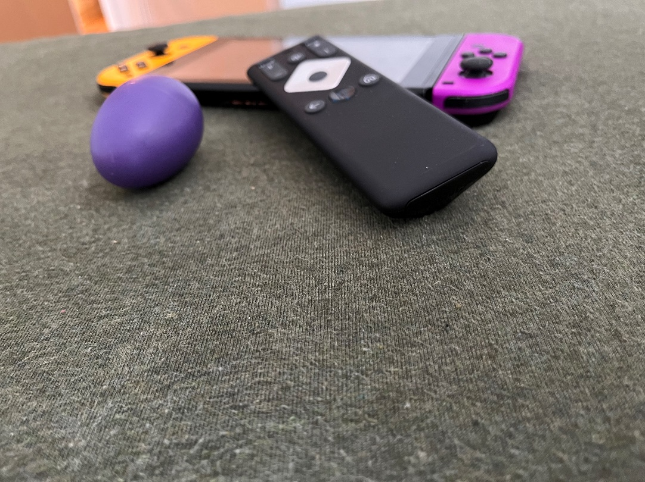Back View